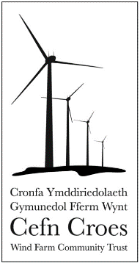

Cronfa Ymddiriedolaeth Gymunedol Fferm Wynt

Cefn Croes Wind Farm Community Trust

Endof Project Report

Group Application

Contact Grant award

Items approved as listed on application | Details of grant expenditure | Amount | Receipts  enclosed*
TOTAL

*Please ensure the receipts attached clearly show the item(s) purchased
(invoices would require a copy of the bank statement to confirm payment).

Have the grant monies been fully utilised for the purpose for which they were awarded? | Yes | No

If not, please confirm any changes and the reasons for these changes:

Please detail who the main beneficiaries were and how funding has benefitted them:

Please attach any photographs (with a brief explanation) or good stories, which provide an insight into what you have achieved through this project.

It is requested that any publicity material you produce, as a result of this grant, displays the Cefn Croes Wind Farm Community Trust logo:

Thank you for your co-operation.

Signature

Name

Position in Organisation

Date

This form should be returned to:

Cefn Croes Wind Farm Community Trust / Ymddiriedolaeth Gymunedol Fferm Wynt Cefn Croes,
C/O Pentir Pumlumon,
Lisburne Offices
Pontrhydygroes
Ceredigion
SY25 6DQ
Registered Charity 1113576

